Computer Programming Lab – 3

1. Write a function to calculate area and perimeter of a rectangle.

#include <stdio.h>

int pr(int len, int brd){

int peri;

peri = 2\*(len+brd);

return (peri);

}

int ar(int len, int brd){

int ara;

ara = (len\*brd);

return (ara);

}

int main()

{

int l, b, p, a;

printf("Enter the length of the rectangle: ");

scanf("%d", &l);

printf("Enter the breadth of the rectangle: ");

scanf("%d", &b);

p = pr(l,b);

printf("The Perimeter of the rectangle is %d\n", p);

a = ar(l,b);

printf("The Area of the rectangle is %d", a);

return 0;

}

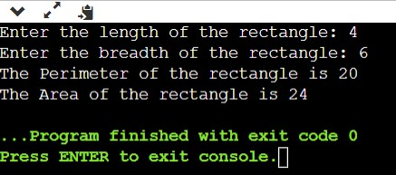

2. Write a function to calculate the factorial of a number (a non-negative integer). The function accepts the number as an argument

#include <stdio.h>

int fact(int number){

int fact = 1, i;

for(i=1; i<=number; i++){

fact = fact\*i;

}

return (fact);

}

int main()

{

int num, Factorial;

printf("Enter the number for which factorial is to be calculated: ");

scanf("%d", &num);

Factorial = fact(num);

printf("The factorial of the number is %d\n", Factorial);

return 0;

}

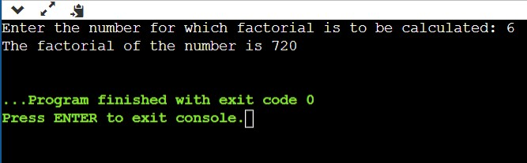

3. Write a function to check whether a number falls in a given range. Take number and range from user.

#include <stdio.h>

int check(int number, int starter, int stopper)

{

if( (number>= starter) && (number<= stopper) )

printf("The enter number is present in the range \n");

else

printf("The enter number is not present in the range");

return 0;

}

void main()

{

int num, start, stop, c;

printf("Enter the number: ");

scanf("%d", &num);

printf("Enter the start value of the range: ");

scanf("%d", &start);

printf("Enter the stop value of the range: ");

scanf("%d", &stop);

c = check(num, start, stop);

}

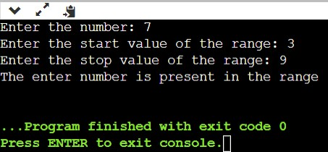

4. Write a function that takes a number as a parameter and check the number is prime or not.

#include <stdio.h>

int prime(int number){

int i, c=0;

for (i = 2; i <= number / 2; ++i) {

if (number % i == 0) {

c = 1;

break;

}

}

if (c == 0)

printf("%d is a prime number.", number);

else

printf("%d is not a prime number.", number);

return 0;

}

void main()

{

int num, Check;

printf("Enter the number: ");

scanf("%d", &num);

Check = prime(num);

}

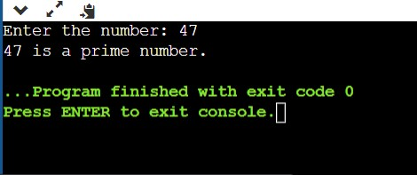

5. Write a function to print largest of three numbers.

#include <stdio.h>

int greatest(int number1, int number2, int number3){

if (number1>number2 && number1>number3)

printf("The number %d is the largest among the entered three numbers", number1);

else if (number2>number3)

printf("The number %d is the largest among the entered three numbers", number2);

else

printf("The number %d is the largest among the entered three numbers", number3);

}

void main()

{

int num1, num2, num3, Check;

printf("Enter the first number: ");

scanf("%d", &num1);

printf("Enter the second number: ");

scanf("%d", &num2);

printf("Enter the third number: ");

scanf("%d", &num3);

Check = greatest(num1, num2, num3);

}

